**Experiment No. 7**

**Title :** Implementation of Bubble Sort

**Problem Statement :** Write a C++ program to arrange the given set of numbers in ascending order using Bubble sort

**Algorithm:**

**Step 1:** Start

**Step 2:** Input the array to be sorted

**Step 3:** Repeatedly travel through the array and compare the two elements at a time and swap them if the first is larger than second element, number of passes will be equal to number of elements in the array.

**Step 4:** Display the Sorted array.

**Step 5:** Stop.

**Program:**

// Bubble Sort

// To sort given elements in Ascending order

#include<iostream>

using namespace std;

int main()

{

int array[50], n, i, j, k, temp;

cout<<"Enter the size of array: ";

cin>>n;

cout<<"Enter the array elements to be sorted:";

//To read the array

for(i=0;i<n;++i)

cin>>array[i];

cout<<"Array before sorting :";

for(i=0;i<n;++i)

cout<<" "<<array[i];

for(i=1;i<n;++i) // i keeps track of the no. of passes

{

{

for(j=0;j<(n-i);++j)

if(array[j]>array[j+1])

{

temp=array[j];

array[j]=array[j+1];

array[j+1]=temp;

}

}

//To print the array elements after every pass

cout<<"\n\n Array after Pass "<<i<<":" ;

for(k=0;k<n;++k)

cout<<" "<<array[k];

}

cout<<"\n\nArray after bubble sort:";

for(i=0;i<n;++i)

cout<<" "<<array[i];

return 0;

}

**Output:**

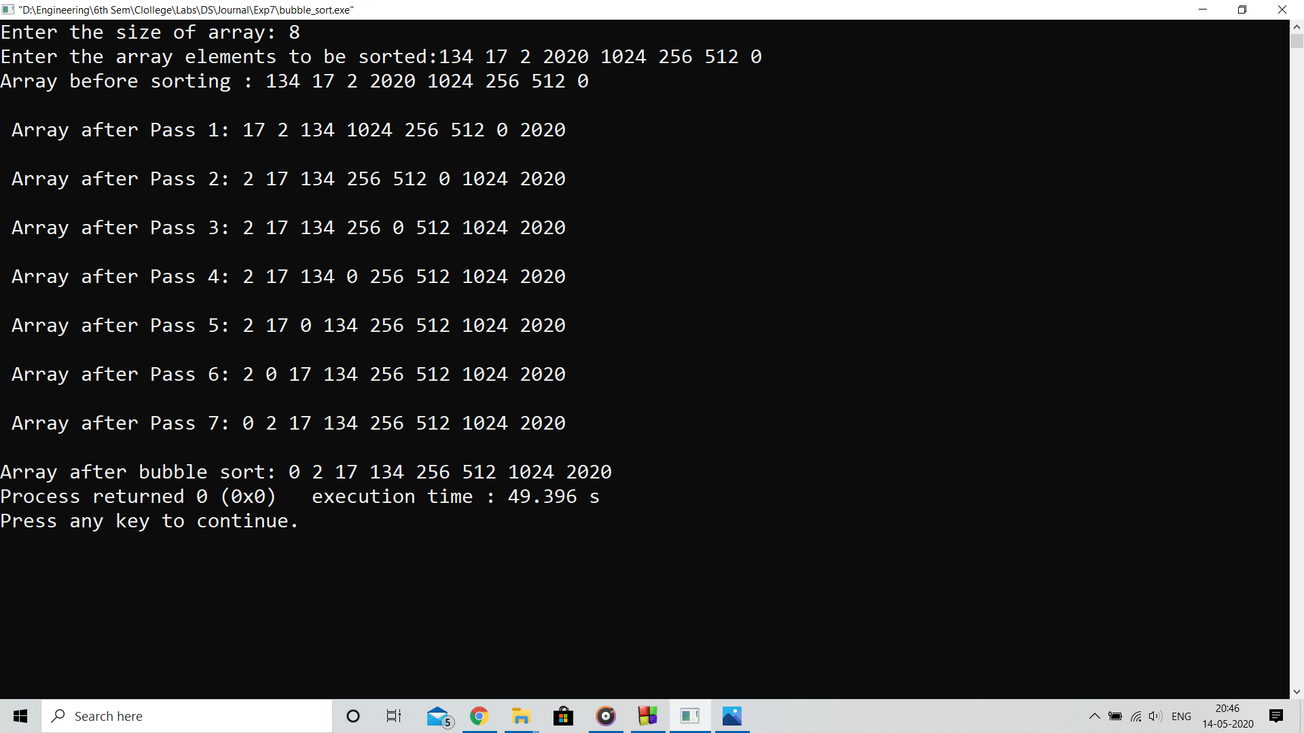

**Analysis:**

Bubble sort algorithm has to make n*n iterations to sort an array of n elements and which is time consuming process

**Limitation:**

The code will take very long time to sort the elements of the range of Mbytes or Gbytes array which will increase the latency of the overall software using this algorithm